2nd International Conference
“SHAPING THE FUTURE: DIGITAL ECONOMY AND RECENT TECHNOLOGY TRENDS”
June 23-24, 2022
Tirana, Albania

Important Dates
►Abstract Submission: 5 May 2022
►Submission Approval: Within a week from submission
►Fee Payment Deadline: 20 May 2022
►Full Paper Submission: 5 June 2022
Submit your abstract to: conferences@cit.edu.al

In cooperation with:

FORM OF ABSTRACT
Title of Paper
(14 points Times New Roman, Bold, Centered)
Name and Surname – 1
The institution where you work (12 Times New Roman, center, for author number 1)
Name and Surname – 1
The institution where you work (12 Times New Roman, center, for author number 2)

Abstract
The summary should be limited to a maximum of 200-250 words. The abstract is a single-spaced, an introduction paragraph, and a summary of the most important elements of the paper. The authors are required to clearly state the content and purpose of their study, including introductions, research questions, applied scientific methods, findings, key results, recommendations, and suggestions.
The abstract should be written in Microsoft Word, 12 Times New Roman, justified.

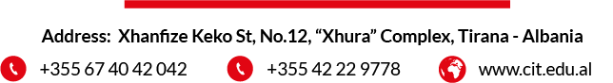
Keywords: This section should include at most 5 study-related keywords, separated by commas. (12 Points Times New Roman, Italicize every word)

