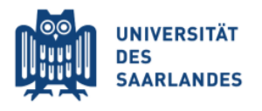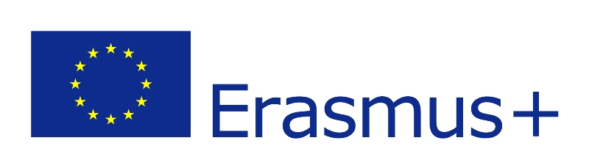
INTERNATIONAL RELATIONS AND PROJECT OFFICE

SUBJECT: CALL FOR APPLICATIONS ERASMUS+ KA107-2020 SCHOLARSHIPS
FOR STUDENTS MOBILITY FROM PARTNER COUNTRIES
Student Mobility Between Program Countries, University of Saarland in Germany
and Partner Countries, the Canadian Institute of Technology in Tirana, Albania. (KA107)
Fall semester Academic Years 2022-2023
TO : STUDENTS OF ENGINEERING
The Erasmus+ Program of the European Commission promotes the mobility of students. The action KA107 of this program provides funding for exchange mobility with partner countries.
University of Saarland in Germany and the Canadian Institute of Technology in Tirana, has been awarded with scholarships for Students of Engineering under the action KA107 based on the Joint Interinstitutional Agreements.
The Erasmus+ KA1 - Mobility of persons for learning purposes - Action: Student Mobility between programme countries and partner countries (KA107) aims at consolidating the institutional relations between the participating universities and to explore new possibilities for cooperation. For more information concerning the study offer at Saarland University, please follow the link: https://saarland-informatics-campus.de/en/studium-studies/
Action KA107 will be a great opportunity to raise the partners' profile and increase the cooperation in new geographical areas, especially in those regions considered as a priority by the Canadian Institute of Technology.
The project goal is to expand the training and knowledge of the participants as well as to foster the exchange of skills and experiences between the participating countries. Students must return to their countries of origin once the mobility period has concluded in order to put into practice the knowledge acquired and promote the transfer of skills and intercultural liaisons.
Aim for the Call:
Call for applications for direct grants for the Canadian Institute of Technology(CIT) students international mobility at the University of Saarland, under the Erasmus+ KA107 programme "Mobility of students between programme and partner countries" aimed for 2(two) outgoing ENGINEERING students: 1(One) Bachelor Student for One Semester for Learning Mobility and 1(one) Master Student for training, 2 (two) months training mobility, during the Fall Semester of the Academic Year 2022-2023.

Features of The Mobility for outgoing Student:
- Mobility studies will be aimed at those studying degree subjects taught at the university.
- They must have knowledge of English language proficiency required, as given in section "Award criteria for the grant".
- For study mobilities, of 5(five) months per type of qualification (bachelor's). The maximum grant for the stay will be 5 months.
- For training mobilities of 2(two ) months per type of qualification (masters's). The maximum grant for the stay will be 2(two) months.
Nomination criteria for students:
Applications will be prioritized according to the Nomination Criteria’s for students as declared in the CIT Erasmus+ Guidelines: Document I.A: The Erasmus+ Applicants Nomination Process and Candidate Evaluation Criteria (attached to this call).
- Academic performance. 70 points
  - Average grades. 50 points (Registrar evidence);
  - Academic affairs involvement. Conference participation, study and research involvements, academic competitions etc. 10 points (a written department evaluation);
  - Good behaviour and discipline: 10 points (a written department evaluation);
- The number of classes and/or training courses that comply with classes/training courses agreed with partnering institutions. 15 points. (Learning agreements)
- Participation in extracurricular activities, sports achievements, achievements in art, participation in international activities, participation in other relevant events, 15 points. (Written evaluation by Student Affairs Office);
The exclusion criterion is English proficiency (certificates, B1-B2)
Sum of the Grants:
- The Erasmus+ provides a scholarship of € 800,00 per month to Germany. (Student Mobility)
- The amount of the Erasmus+ grant will be transferred in full, after the subscription of the Grant Agreement, within 30 days from the beginning of the mobility.
- Travel Allowance also will be provided to student as well. The amount will depend on the distance between the institution of origin and the institution of destination according to the European Commission’s regulations. There is 500 - 1999 km distance between Albania and Germany which is 275 € per participant.

Rights of the beneficiary:
- To perform the entire mobility period awarded without the possibility of extending the scholarship.
- To receive the scholarship according to the amounts set out in the Erasmus+ Programme guidelines. The expenses not covered by the scholarship will be borne by the beneficiary.
- To benefit from tuition fee waiver as an exchange student, notwithstanding other fees for the use of certain services or activities that might be applicable.
- To receive information and advice on the application procedure, as well as pre-departure and onsite guidance.
- To have the study period abroad recognized by the sending university.

Obligations of the beneficiary:
- To obtain the Visa for the stay in the receiving country.
- To carry out the mobility stay according to the proposal and dates committed, during 2022/23 Fall semester;
- In the event of force majeure, the mobility period must be modified by signing an addendum to the agreement.
- To complete all procedures and fill in the required documents as required by the Erasmus+ Programme, before, during and after the mobility period, meeting the deadlines established:
Before mobility:
- Signature of the Grant Agreement
- Signature of the Learning Agreement Proposal

After mobility:

- Submission of the Mobility Certificate
- Online mobility final assessment survey
- Transcript of records and recognition at the sending institution in order to complete table D after the mobility of the learning agreement.

- Any other obligation inherent to the Erasmus+ Programme and the internal regulations of the sending and receiving institutions.

Nomination deadlines by partner institutions:
- This call for applicants is open no later than 10th, of June 2022 - Erasmus+ outgoing mobility for the fall semester.
- Nominations of selected students must be sent to Saarland University no latter than 15June 2022.
Procedures for Erasmus+ outgoing students to University of Saarland in Germany:
After being officially nominated, Erasmus+ outgoing students receive the University of Saarland, Welcome Message, with a requested document for the registration.

Students have to prepare the following documents:
- one passport-size photo (good quality, JPG format, 4MB max.);
- transcript of records (certificate prepared by the home university);
- learning Agreement;
- English or German certificate (at least B1 level) - check the "Recognized certification" tab;
- Copy of a valid ID or passport.
- Students will be notified if other documents will be required;

All the application documents must be sent electronically to the following address mobilityapplications@cit.edu.al no latter than 10th of June 2022.
The list of nominated students will be sent to Saarland University no latter than 15th of June 2022.
Please feel free to contact the International & Project Office (internationaloffice@cit.edu.al ) in case you are interested for more information.

