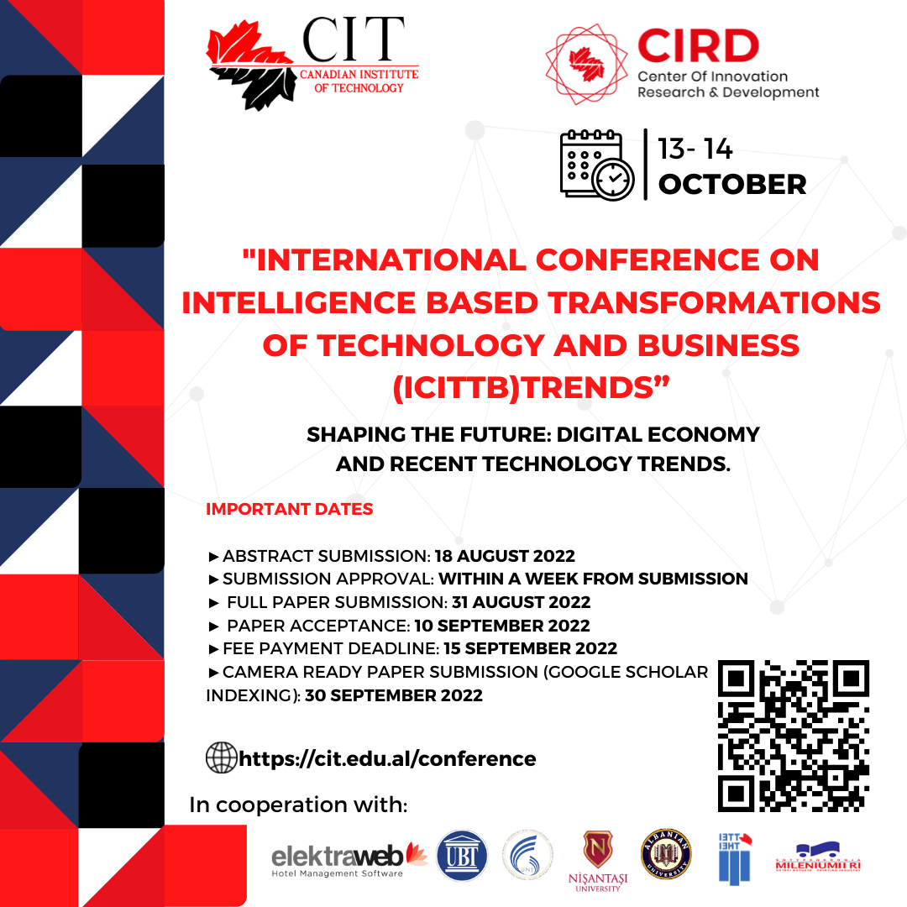

International Conference on Intelligence-based Transformations of Technology and Business (ICITTB)
“SHAPING THE FUTURE: DIGITAL ECONOMY AND RECENT TECHNOLOGY TRENDS”
October 13-14, 2022 │Tirana, Albania

FORM OF ABSTRACT
Title of Paper
(14 points Times New Roman, Bold, Centered)
Name and Surname – 1
The institution where you work (12 Times New Roman, center, for author number 1)
Name and Surname – 1
The institution where you work (12 Times New Roman, center, for author number 2)

Abstract
The summary should be limited to a maximum of 200-250 words. The abstract is single-spaced, an antroduction paragraph, and a summary of the most important elements of the paper. The authors are required to clearly state the content and purpose of their study, including introductions, research questions, applied scientific methods, findings, key results, recommendations, and suggestions.
The abstract should be written in Microsoft Word, 12 Times New Roman, and justified.

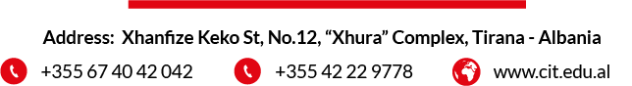
Keywords: This section should include at most 5 study-related keywords, separated by commas. (12 Points Times New Roman, Italicize every word)

